**Win vs Loss Statistics:**

* 76.8 PPG in Wins, 65.8 PPG in Losses
  + 8-0 when scoring over 80 points
* 64.5 PPG Allowed in Wins, 72.1 PPG Allowed in Losses
  + 11.0 PPG spread in points scored splits vs. 7.6 PPG spread in points allowed splits
  + **Shows our defense was more consistent than our offense**
* 59.2 Field Goals Attempted in Wins vs 59.6 Field Goals Attempted in Losses
  + Shows that our pace of play didn’t really impact success
* 48% FG% in Wins, 41% in Losses
  + 22-5 when we shot over 40% from the field
* 34% 3P% in Wins, 27% 3P% in Losses
  + **15-5 when attempting 20+ threes**
  + 19-7 when making 5+ threes
* 16.7 FT attempted in Wins, 15.2 FT attempted in Losses
  + 9-1 when attempting 20+ free throws
* 8.9 Offensive Rebounds in Wins, 9.6 Offensive Rebounds in Losses
  + Interesting negative split here
* Won the rebounding battle by 5.1 total rebounds in Wins, lost the rebounding battle by 2.7 total rebounds in Losses
  + **19-3 in games we won the rebounding battle**
* 12.9 APG in Wins, 9.0 APG in Losses
  + **15-1 when getting 12+ assists**
* 9.3 TOV in Wins, 10.8 TOV in Losses
  + 12-2 in games we had less than 10 turnovers
* 16.6 PF in Wins, 18.4 PF in Losses
* Allowed 16.9 free-throw attempts in Wins, 21.0 in Losses
* Allowed 6.8 offensive rebounds in Wins, 8.6 in Losses
  + 20-5 when allowing less than 10 offensive rebounds
* Most of the opponent statistics didn’t have significant win/loss splits

I created a random forest. This type of model runs through our schedule 1000 times and predicts, given the statistics of the game log, whether we won or lost.

The model correctly predicted the result 68% of the time. However, the model was 95% accurate in its prediction when we actually won the game (meaning when the model predicted a win, we did actually win the game). This shows that we consistently won games in similar ways.

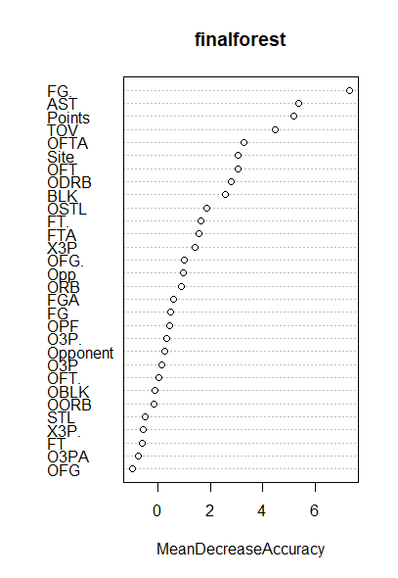

This graph ranks variables based on if the given statistic was removed from the model, how much would the accuracy of the prediction of Win/Loss decrease. The values on the x axis do not mean anything in particular other than stating the significance of the statistic. In this graph, statistics with a “MeanDecreaseAccuracy” over 4 are statistically significant.

Based on the graph:

* The amount of points we scored, our FG%, and Assist count were the 3 most important statistics in determining a win or loss. This seems kind of obvious, however the number of points our opponent scored was not significant in predicting a win or loss. This tells us that our offense as a whole largely drove team success.
* The next tier of important statistics is turnovers, everything below that probably isn’t super significant
* We could conclude from this model that since our defensive statistics weren’t deemed super significant, that our offense was the X factor, regardless of who we played.